EXTERIOR COVER

DELETE THE FIGURES AND NOTES BEFORE PRINTING!
4 cm

INVESTIGATIONS OF ISTANBUL STOCK EXCHANGE NATIONAL 100 INDEX (BIST–100) BY USING DATA MINING AND FINANCIAL NETWORK TECHNIQUES

2014
MASTER THESIS
COMPUTER ENGINEERING
Make spaces between blocks equal Title

YUSUF YARGI BAYDİLLİ
Advisor

Assist.Prof.Dr. Şafak BAYIR
5 cm
INVESTIGATIONS OF ISTANBUL STOCK EXCHANGE NATIONAL 100 INDEX (BIST–100) BY USING DATA MINING AND FINANCIAL NETWORK TECHNIQUES
INNER COVER

DELETE THE FIGURES AND NOTES BEFORE PRINTING!

5 cm

10 cm

Yusuf Yargı BAYDİLLİ

15 cm

T.C.
Karabuk University
Institute of Graduate Programs
Department of Computer Engineering
Prepared as
Master Thesis
Advisor

Assist.Prof.Dr. Şafak BAYIR

KARABUK
Accordint to defense exam date
May 2014
5 cm
I certify that in my opinion the thesis submitted by Yusuf Yargı BAYDİLLİ titled “INVESTIGATIONS OF ISTANBUL STOCK EXCHANGE NATIONAL 100 INDEX (BIST–100) BY USING DATA MINING AND FINANCIAL NETWORK TECHNIQUES” is fully adequate in scope and in quality as a thesis for the degree of Master of Science.

Assist.Prof.Dr. Şafak BAYIR ..........................
Thesis Advisor, Department of Computer Engineering

This thesis is accepted by the examining committee with a unanimous vote in the Department of Computer Engineering as a Master of Science thesis. May 8, 2014

Examining Committee Members (Institutions) Signature

Chairman : Prof.Dr. Fatih V. ÇELEBİ (YBU) ..........................

Member : Assist.Prof.Dr. Şafak BAYIR (KBU) ..........................

Member : Assist.Prof.Dr. Salih GÖRGÜNOĞLU (KBU) ..........................

The degree of Master of Science by the thesis submitted is approved by the Administrative Board of the Institute of Graduate Programs, Karabuk University.

Prof. Dr. Hasan SOLMAZ ..........................
Director of the Institute of Graduate Programs

“I declare that all the information within this thesis has been gathered and presented in accordance with academic regulations and ethical principles and I have according to the requirements of these regulations and principles cited all those which do not originate in this work as well.”

Yusuf Yargı BAYDİLLİ

ABSTRACT

M. Sc. Thesis

INVESTIGATIONS OF ISTANBUL STOCK EXCHANGE
NATIONAL 100 INDEX (BIST–100) BY USING DATA MINING AND
FINANCIAL NETWORK TECHNIQUES

Yusuf Yargı BAYDİLLİ

Karabük University
Institute of Graduate Programs
The Department of Computer Engineering

Thesis Advisor:
Assist. Prof. Dr. Şafak BAYIR
May 2014, 131 pages

Stock market is a complex system. Stocks in this system are in various relationships with stocks in own sector and the other sectors. One of the methods, that are used to analyze this relationship, is stock correlation network technique. In this type of analysis, a network that has all stocks is created and this network is used to examine market movements, both computing minimum spanning tree (MST) by using various algorithms or/and hierarchical structural techniques.

Key Words : Finance, stock market, econophysics, financial network, stock correlation network, data mining, topology, graph theory, minimum spanning tree, hierarchical tree.
Science Code : 902.2.042

ÖZET

Yüksek Lisans Tezi

İSTANBUL BORSASI ULUSAL 100 ENDEKSİNİN (BİST–100)
VERİ MADENCİLİĞİ VE FİNANSAL AĞ
TEKNİKLERİYLE İNCELENMESİ

Yusuf Yargı BAYDİLLİ

Karabük Üniversitesi
Fen Bilimleri Enstitüsü
Bilgisayar Mühendisliği Anabilim Dalı

Tez Danışmanı:
Yrd. Doç. Dr. Şafak BAYIR
Mayıs 2014, 131 sayfa

Borsa karışık bir sistemdir. Bu sistem içerisinde bulunan hisse senetlerinin, hem kendi sektörü içindeki hisse senetleriyle, hem de diğer sektörlerdekilerle çeşitli ilişkileri mevcuttur. Bu ilişkilerin analizinde kullanılan yöntemlerden bir tanesi de korelasyon ağı analizidir. Bu analiz tipinde tüm hisse senetlerini içeren bir ağ oluşturulur ve çeşitli algoritmalarla en kısa yol ağacı hesaplanarak ve/veya hiyerarşik sınıflandırma teknikleriyle, piyasa hareketleri incelenir.

Anahtar Kelimeler : Finans, borsa, ekonofizik, finansal ağ, korelasyon ağı, veri madenciliği, topoloji, graf teori, en kısa yol ağacı, hiyerarşik sınıflandırma ağacı.
Bilim Kodu : 902.2.042

ACKNOWLEDGMENT

First of all, I would like to give thanks to my advisor, Assist. Prof. Dr. Şafak BAYIR, for his great interest and assistance in preparation of this thesis.

CONTENTS
Page
APPROVAL ii
ABSTRACT iv
ÖZET vi
ACKNOWLEDGMENT viii
CONTENTS ix
LIST OF FIGURES xii
LIST OF TABLES xv
SYMBOLS AND ABBREVITIONS INDEX xvi

PART 1 1
INTRODUCTION 1

PART 2 3
LITERATURE REVIEW 3

PART 3 14
THEORETICAL BACKGROUND 14
3.1. NETWORKS AND GRAPH THEORY 14
3.1.1. Basic Definition 14
3.1.2. Links and Their Structures 16
3.1.3. Basic Structural Properties 17
3.1.4. Advanced Properties 18
3.2. CLUSTERING 19
3.2.1. Clustering Algorithms 21
3.2.2. Hierarchical Clustering 22
3.2.2.1. Distance Measure 22
3.2.2.2. Single-Link, Complete-Link & Average-Link Clustering 23
3.3. CORRELATION BASED NETWORKS 24
Page
3.3.1. Minimum Spanning Tree (MST) 25
3.3.1.1. The Only Minimum Spanning Tree Algorithm 26
3.3.1.2. Borûvka’s Algorithm 27
3.3.1.3. Prim’s Algorithm 28
3.3.1.4. Kruskal’s Algorithm 30
3.4. STOCK CORRELATION NETWORK 31
3.4.1. Networks of Financial Time Series 32
3.4.1.1. Stocks 32
3.4.1.2. Liquid and Illiquid Stocks 32
3.4.1.3. Sectors 33
3.4.1.4. Indices 33
3.4.1.5. Desired Time Series Data 34
3.4.2. Correlation 35
3.4.2.1. Correlation Coefficient 35
3.4.2.2. Distance 37
3.4.3. Statistical Moments 38
3.4.4. Normal (Gaussian) Distribution 39

PART 4 41
METHODOLOGY 41
4.1. ISTANBUL STOCK EXCHANGE 42
4.1.1. Bourse Istanbul Indices 43
4.1.2. BIST–100 Companies 44
4.1.3. Data Scale 46
4.2. BASIC CALCULATIONS 47
4.2.1. Calculation of Correlation Coefficients 47
4.2.2. Calculation of Metric Distances 48
4.3. STATISTICAL CALCULATIONS 50
4.3.1. Distribution of Correlation Coefficients 51
4.4. STOCK CORRELATION NETWORK OF BIST–100 53
4.4.1. Constructing MST 53
4.4.1.1. Properties of MST 57
Page
4.4.1.2. Probing MST 61
4.4.2. Constructing Hierarchical Tree 67
4.4.2.1. Probing HT 69
4.4.3. Portfolio Optimization 72
4.4.3.1. Modern Portfolio Theory 72
4.4.3.2. Probing MPT 74
4.5. BIST–100 CASE STUDY 77
4.5.1. Crisis: Local and Global Economical Factors 77
4.5.1.1. General View of Global Factors 82
4.5.1.2. Effects of Global Factors on BIST–100 84

PART 5 88
SUMMARY 88
5.1. RESULTS & DISCUSSION 89
5.2. RECOMMENDATIONS 95
REFERENCES 97

APPENDIX A. LARGER VIEWS OF MSTs 102
APPENDIX B. LARGER VIEWS OF ALCA HTs 109
APPENDIX C. RISK-VOLATILITY TABLE 113
APPENDIX D. FIGURES OF LOCAL ECONOMICAL FACTORS 115
APPENDIX E. FIGURES OF MSTs FOR 2003–2013 119
RESUME 131

LIST OF FIGURES
Page
Figure 3.1. Visualization of a network. 14
Figure 3.2. Basic graph representation. 15
Figure 3.3. Graphical example of clustering. 20
Figure 3.4. A dendrogram. 23
Figure 3.5. A weighted graph and its minimum spanning tree. 25
Figure 3.6. The ‘bad’ component of F. 27
Figure 3.7. Borûvka’s algorithm. 28
Figure 3.8. Jarník’s algorithm. 29
Figure 3.9. Kruskal’s algorithm. 30
Figure 3.10. Distribution model. 39
Figure 4.1. Opening prices of two cement companies. 46
Figure 4.2. Logarithmic return scale of two stocks. 46
Figure 4.3. Correlation coefficient matrix of ISE National 100 Index. 48
Figure 4.4. Distance matrix. 50
Figure 4.5. BIST–100 opening values. 51
Figure 4.6. Distribution of correlation coefficients. 51
Figure 4.7. Statistical moments of correlation coefficients. 52
Figure 4.8. Normalized tree length of MSTs. 55
Figure 4.9. MST of BIST–100 in 2011–2013. 56
Figure 4.10. Edge betweenness of MST. 59
Figure 4.11. Degree distribution-k of MST. 60
Figure 4.12. Sector view of BIST–100 from MST. 62
Figure 4.13. Sub-sectoral view and clusters of BIST–100 in MST. 63
Figure 4.14. Classification of stocks by indices. 66
Figure 4.15. Comparison of filtered correlation matrices. 68
Figure 4.16. Hierarchical tree of BIST–100 stocks. 70
Figure 4.17. Sectoral view of BIST–100 stocks from HT. 71
Figure 4.18. Index view of BIST–100 from HT. 72
Page
Figure 4.19. Efficient frontiers of six-month periods of BIST–100. 73
Figure 4.20. Efficient frontier graph of BIST–100. 74
Figure 4.21. BIST-100 opening values for 2003–2013. 82
Figure 4.22. MST of BIST–100 and global factors for 2003–2013. 83
Figure 4.23. Normalized tree length for 2003–2013. 86
Figure 4.24. Power-law exponent values for 2003–2013. 86
Figure Appendix A.1. Larger views of six-month periods. 103
Figure Appendix A.2. Larger view of MST for 2011–2013. 105
Figure Appendix A.3. Larger view of MST (sector) for 2011–2013. 106
Figure Appendix A.4. Larger view of MST (sub-sector) for 2011–2013. 107
Figure Appendix A.5. Larger view of MST (index) for 2011–2013. 108
Figure Appendix B.1. Larger view of HT (sub-sector). 110
Figure Appendix B.2. Larger view of HT (sector). 111
Figure Appendix B.3. Larger view of HT (index). 112
Figure Appendix D.1. Current account. 116
Figure Appendix D.2. Gross and net external debt. 116
Figure Appendix D.3. Interest rates. 116
Figure Appendix D.4. Gross domestic product in constant prices. 117
Figure Appendix D.5. Gross domestic product in current prices. 117
Figure Appendix D.6. 2007-2013 export and import values. 117
Figure Appendix D.7. Growth rates by constant and current prices. 118
Figure Appendix D.8. Gross domestic product by purchasers current pricers. 118
Figure Appendix D.9. Gross domestic product by purchasers constant pricers. 118
Figure Appendix E.1. MST of global financial assets for 2003. 120
Figure Appendix E.2. MST of global financial assets for 2004. 121
Figure Appendix E.3. MST of global financial assets for 2005. 122
Figure Appendix E.4. MST of global financial assets for 2006. 123
Figure Appendix E.5. MST of global financial assets for 2007. 124
Figure Appendix E.6. MST of global financial assets for 2008. 125
Figure Appendix E.7. MST of global financial assets for 2009. 126
Figure Appendix E.8. MST of global financial assets for 2010. 127
Figure Appendix E.9. MST of global financial assets for 2011. 128
Page
Figure Appendix E.10. MST of global financial assets for 2012. 129
Figure Appendix E.11. Statistical moments of correlations coefficients of global financial assets for 2003–2013. 130

LIST OF TABLES
Page
Table 4.1. ISE indices and sub-sectors. 44
Table 4.2. BIST–100 stocks in October–December 2012. 45
Table 4.3. Properties of MST network. 57
Table 4.4. Node properties of MST network. 58
Table 4.5. Out-range stocks. 75
Table Appendix C.1. Full-list of risk-volatility. 114

SYMBOLS AND ABBREVITIONS INDEX

SYMBOLS

$ρ$ : correlation coefficient
$σ$ : standard deviation

ABBREVITIONS

cov : covariance
log : logarithmic
var : variance
ALCA : Average Linkage Cluster Analysis

PART 1

INTRODUCTION

Stock market (or bourse) is a highly organized market where stocks and shares are bought and sold. The stocks in market exist in several sectors. All stocks in same sectors and all sectors in market act in a relationship among them. This relationship can be in related or far from each other. Analyzing these relationships helps to investigate current market dynamics, predict market movements and determine major stocks giving direction to sectors and portfolio.

PART 2

LITERATURE REVIEW

In the last decade, financial networks have attracted more attention from the research community. The efficient market paradigm states that stock returns of financial price time series are unpredictable. Within this paradigm, time evolution of stock returns is well described by random process. Several empirical analyses of real market data have proven that returns of time series are approximately described by non-redundant time series. The absence of redundancy is not complete in real markets and the presence of residual redundancy has been detected. A minimized degree of redundancy is required to avoid the presence of arbitrage opportunities. There are many studies about this topic, which was firstly introduced by Edward Mantegna.

In his work, the motivation of the study was twofold. The first motivation concerned the search for the kind of topological arrangement, which was present among the stocks of a portfolio traded in a financial market. The second motivation was the search of empirical evidence about the existence and nature of common economic factors, which drove the time evolution of stock prices. The observable, which was used to detect the topological arrangement of the stocks, was the synchronous correlation coefficient of the daily difference of logarithm of closure price of stocks.

He created hierarchical tree and minimum spanning tree by using Dow Jones 30 and S&P (Standard & Poor’s) 500 Index in a time from July 1989 to October 1995. The reason of choosing these indices was that they mainly describe the performance of the New York Stock Exchange. With this study, he showed that the MST and the associated sub-dominant ultra-metric hierarchical tree, which were obtained starting from the distance matrix and selected a topological space for the stocks of a portfolio traded in a financial market, are able to give an economic meaningful taxonomy.
According to him, this topology is useful for theoretical description of financial markets and search of economic common factors affecting specific groups of stocks. The topology and hierarchical structure associated to them could be obtained by using information in the time series of stock prices only. This result showed that time series of stock prices are carrying valuable (and detectable) economic information [1].

PART 3

THEORETICAL BACKGROUND

Papers introduced previous chapter showed that the results of this researches are very useful for understanding whole stock market and dynamics. Moreover, they give information about predicting market movements. To earn these benefits, much knowledge must be known and series of calculations must be done. In this part, this knowledge and calculations would be represented and the way should be followed to construct a financial network for a stock market would be explained.

3.1. NETWORKS AND GRAPH THEORY

3.1.1. Basic Definition

In information technology, a network is a series of points or nodes interconnected by communication paths. Networks can interconnect with other networks and contain sub-networks, as can be seen in Figure 3.1 [17].

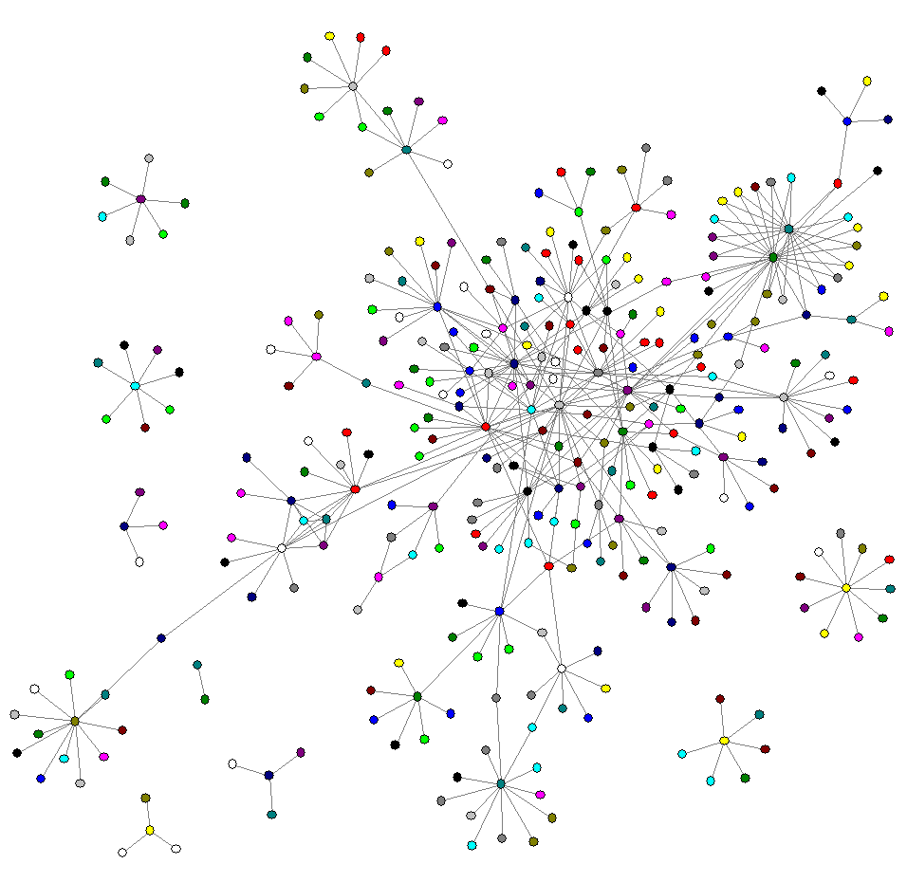

Figure 3.1. Visualization of a network [18].
A graph is a symbolic representation of a network and its connectivity. It implies an abstraction of the reality, so, it can be simplified as a set of linked nodes. The following elements are fundamental at understanding graph theory:

- A graph G is a set of vertex (nodes) v connected by edges (links) e. Thus G = (v, e).
- Vertex (Node): A node v is a terminal point or an intersection point of a graph.
- Edge (Link): An edge e is a link between two nodes. The link (i, j) is initial extremity of i and terminal extremity of j.
- Buckle (Loop or Self edge): A link that makes a node correspond to itself is a buckle [19].

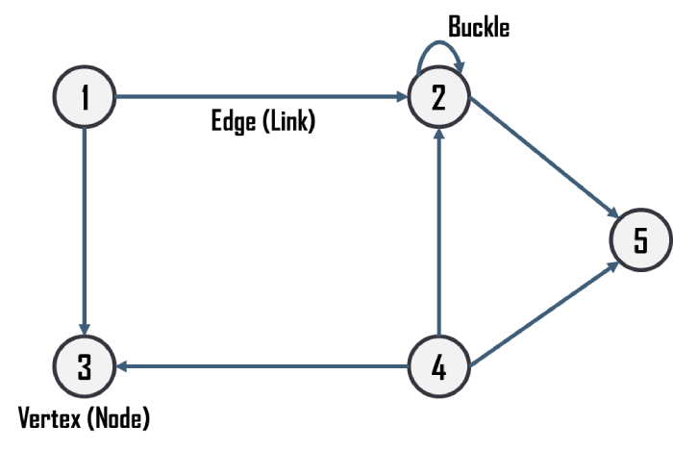

Figure 3.2. Basic graph representation [20].

3.4.1.1. Stocks

In accounting, there are two common uses of the term stock. One meaning of stock refers to the goods on hand which is to be sold to customers. In that situation, stock means inventory. The term stock is also used to mean the ownership shares of a corporation. For example, an owner of a corporation will have a stock certificate, which provides evidence of his or her ownership of a corporation’s common stock or preferred stock. The owner of the corporation’s common or preferred stock is known as a stockholder [32].

3.4.1.2. Liquid and Illiquid Stocks

Liquid Stocks

An asset that can be converted into cash quickly and with minimal impact to the price received. Liquid assets are generally regarded in the same light as cash because their prices are relatively stable, when they are sold on the open market. For an asset to be liquid, it needs an established market with enough participants to absorb the selling without materially influencing the price of the asset. There also needs to be a relative ease in the transfer of ownership and the movement of the asset. Liquid assets include most stocks, money market instruments and government bonds. The foreign exchange market is deemed to be the most liquid market in the world because trillions of Dollars exchange hands each day, making it impossible for any one individual to influence the exchange rate [33].

Illiquid Stocks

It is the state of a security or other asset that cannot easily be sold or exchanged for cash without a substantial loss in value. Illiquid assets also cannot be sold quickly because of a lack of ready and willing investors or speculators to purchase the asset. The lack of ready buyers also leads to larger discrepancies between the asking price (from the seller) and the bidding price (from a buyer) than would be found in an orderly market with daily trading activity. Illiquid securities carry higher risks than liquid ones; this becomes especially true during times of market turmoil, when the ratio of buyers to sellers may be thrown out of balance. During these times, holders of illiquid securities may find themselves unable to unload them at all, or unable to do so without losing a lot of money [34].

- Arithmetic return is:

$$r_{arith}=\frac{V_{f}-V_{i}}{V_{i}} \text{(3.3)}$$

r_{arith} sometimes refers to as yield.

PART 4

METHODOLOGY

In brief, it has been shown that many natural and social systems display unexpected statistical properties of links connecting different elements of the system and cannot therefore be described in terms of random graphs. The fact that financial markets behave as a complex system with huge amounts of available data has resulted in bringing in new approaches developed during the past decades such as, network structures and characterizations, which help towards our understanding of the dynamics of economic systems. The process of clustering a set of economic entities can improve economic forecasting and modeling of composed financial entities, for example, stock portfolios.

4.1. ISTANBUL STOCK EXCHANGE

Istanbul Stock Exchange (ISE) or Bourse Istanbul (BIST) began its operation in 1986 and has been the only stock exchange in Turkey. It has demonstrated a considerable growth since its establishment in 1986. The total market capitalization of the firms traded increased from US$ 938 million at the end of 1986, to US$ 30.8 billion at the end of 1996 and US$ 202.8 billion at the end of 2012. Another noticeable growth was observed in the trading value, which sharply increased from only US$ 13 million in 1986, to over US$ 51 billion in 1995 and US$ 1.5 trillion at the end of 2012. The listing requirements for the securities presenting partnership are regulated by both the ISE and the Capital Market Board. To get the listing of a security at exchange, the following conditions are required: the number of shareholders must be above 100; at least 15% of the paid-in capital must have been publicly offered; at least 3 years must have elapsed since the incorporation date. The exchange administration normally determines and approves a financial structure, which must be at a level to enable the
company to carry out its activities. The firm is also required to show a profit in the previous 2 consecutive years [47].

Table 4.1. ISE indices and sub-sectors [48].

CODE | INDICES and SUB-SECTORS
XU030 | ISE National–30
XU050 | ISE National–50
XU100 | ISE National–100
XUTUM | ISE National–All Shares
XUSIN | ISE National–Industrials
XGIDA | Food, Beverage
XKAGT | Wood, Paper, Printing
XKMYA | Chemical, Petroleum, Plastic
XMADN | Mining
XMANA | Basic Metal
XMESY | Metal Products, Machinery
XTAST | Non-metal Mineral Products
XTEKS | Textile, Leather
XUHIZ | ISE National–Services
XELKT | Electricity
XILTM | Telecommunications
XINSA | Construction
XSPOR | Sport
XTCRT | Wholesale and Retail Trade
XTRZM | Tourism
XULAS | Transportation
XUMAL | ISE National–Financials
XBANK | Banks
XFINK | Leasing, Factoring
XGMYO | Real Estate Investment Trusts
XHOLD | Holding and Investment
XSGRT | Insurance
XUTEK | ISE National–Technology
XBLSM | Information Technology
XSVNM | Defense

PART 5

SUMMARY

Correlation based networks can be obtained from financial markets by investigating time series. “Filtering procedure” applied correlation matrix is created by the returns of a portfolio of financial assets provided to obtain distance matrix which selects a topological space for the stocks traded in a market. Therefore, in this study, it was showed how to associate a correlation matrix with a hierarchical tree and correlation based trees or graphs.

The information forms in correlation based trees and graphs provided some clues about the inter-relations among stocks of different economic sectors, sub-sectors or indices. The ultra-metrication in locally MST that was constructed based on stock price fluctuations help to obtain the information concealed in the correlation coefficients of stock price returns. Besides, from the hierarchical tree of the ultra-metric space, it can be viewed more clearly how a stock specifically correlate to one another. It was also studied the distribution of correlation coefficients and its moments by taking advantage of data mining and statistical techniques. These techniques provide to understand stocks movements better and by using “normalized tree length”, it was maintained to investigate and compare “risk management guide” abilities of statistical, financial and topological methods. Lastly, to analyze performance of “stock correlation network” concept derived information from these techniques used to compare “Modern Portfolio Theory” [1,7–9,12,55].

REFERENCES

- Mantegna, R. N., “Hierarchical structure in financial markets”, The European Physical Journal B, 11 (1): 193–197 (1999).

- Bonanno, G., Vandewalle, N., and Mantegna, R. N., “Taxonomy of stock market indices”, Physical Review E, 62 (6): 7615–7618 (2000).

- Internet: Hawes, L., “Enterprise Software Architecture”, http://www.forbes.com/sites/larryhawes/2012/03/14/enterprise-software-architecture-a-network-of-services-not-a-layered-stack/ (2013).

- Internet: Rodrigue, J. P. and Ducruet, C., “Graph Theory: Definition and Properties”, http://people.hofstra.edu/geotrans/eng/methods/ch1m2en.html (2013).

- Internet: Rodrigue, J. P. and Ducruet, C., “Basic Graph Representation of a Transport Network”, http://people.hofstra.edu/geotrans/eng/methods/basic network.html (2013).

- Acemoglu, D. and Ozdaglar, A., “Graph theory and social networks”, Lecturer Notes, Massachusetts Institute of Technology Department of Economics, Boston, MA, US, 13–18 (2009).

- Internet: Matteucci, M., “Clustering”, http://home.deib.polimi.it/matteucc/ Clustering/tutorial_html/ (2013).

- Internet: Irene, M. M., “Hierarchical Clustering”, http://www.cse.iitb.ac.in/ dbms/Data/Courses/CS632/1999/clustering/node3.html (2013).

- Internet: TIBCO Inc., “Dendrograms and Clustering”, http://stn.spotfire.com/ spotfire_client_help/heat/heat_dendrograms_and_clustering.htm (2013).

- Mantegna, R. N., Lillo, F., Salvatore, M., and Tumminello, M., “Correlation-based networks in finance”, International Workshop and Conference on Network Science, Norwich Research Park, UK, 9, 18 (2008).

APPENDIX A.

LARGER VIEWS OF MSTs

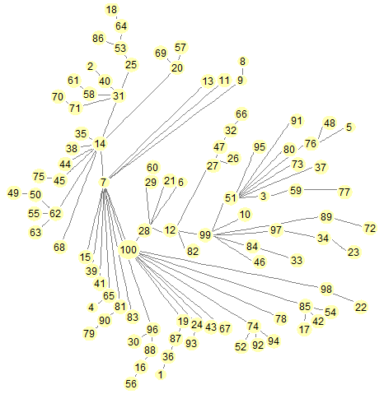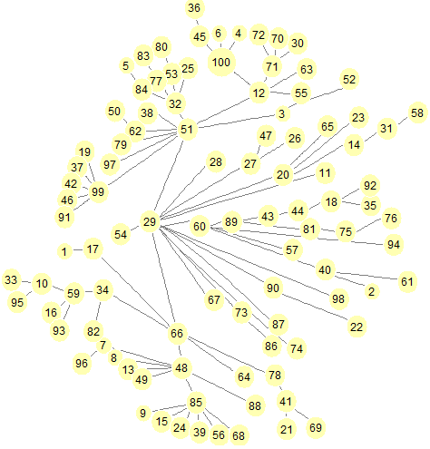

- January–June 2011 b) July–December 2011

Figure Appendix A.1. Larger views of six-month periods.
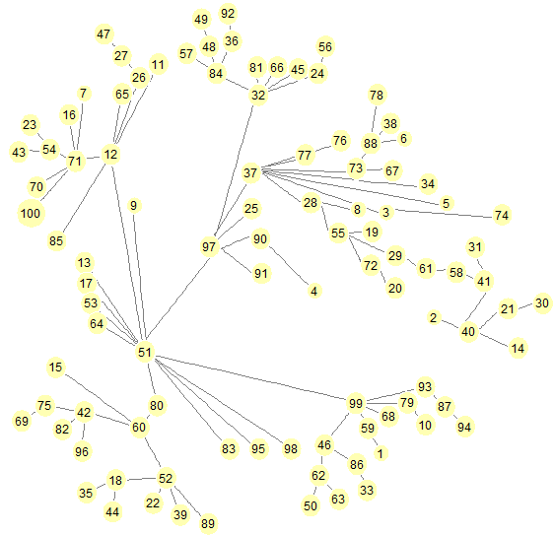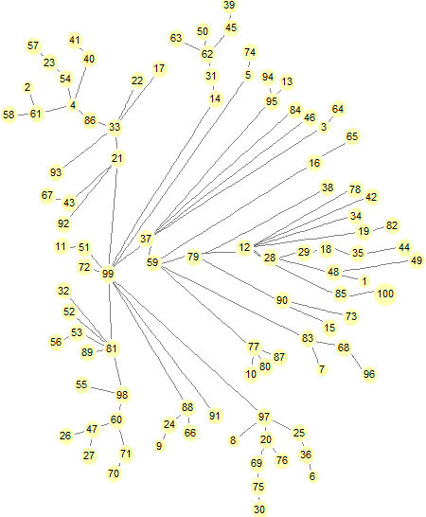

- January–June 2012 d) July–December 2012

Figure Appendix A.1. (Continuing).
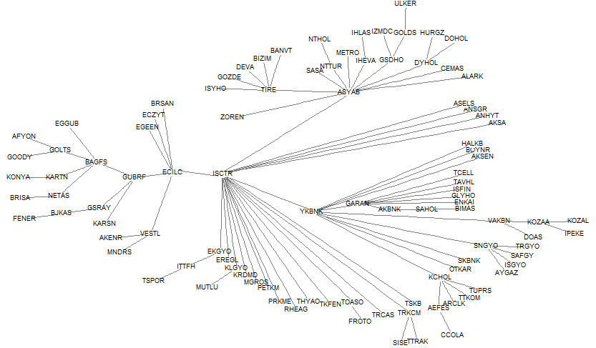

Figure Appendix A.2. Larger view of MST for 2011–2013.

RESUME

Yusuf Yargı BAYDİLLİ was born in Istanbul in 1986 and he graduated first and elementary education in this city. He completed high school education in Üsküdar High School, after that, he started undergraduate program in Abant İzzet Baysal University Department of Physics in 2004. Then in 2010, he started assignment as a Research Assistant in Hakkari University Department of Computer Engineering. To complete M. Sc. education, he moved to Karabük University, where he has been still working as a R. A. for.

CONTACT INFORMATION

Address: Karabük University
Graduate School of Natural & Applied Science
Demir-Çelik Campus/KARABUK

E-mail: yusufbaydilli@karabuk.edu.tr; yusufyargibaydilli@hakkari.edu.tr

